**Accelerometer Filter Design**

*Overview:*

An Accelerometer detects acceleration through a MEMS device. As an accelerometer works with quickly varying measurements, most of the noise present in an accelerometer is contained in a lower bandwidth.

Using the Matlab Filter Toolbox, a Low pass filter was designed with the following parameters:

Filter Type: Low-Pass, Butterworth, 4th Order.  
Filter Cutoff Frequency: 20 Hz  
Filter Equation:

$$H\left(s\right)=\frac{.001(.0199s^{4}+.0797s^{3}+.1195s^{2}+.0797s+.0199}{s^{4}-3.6353s^{3}+4.9709s^{2}-3.0293s+.6941}$$

Accelerometer Output: $∆a_{x},∆a_{y},∆a_{z}$

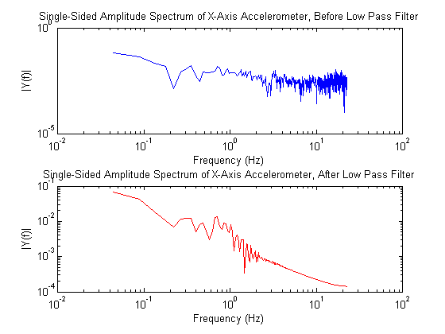

Figure 1. Accelerometer Filter Results

**Gyroscope Filter Design**

A Gyroscope detects rotational movement through a MEMS device. As a gyroscope works with measurements that are much slower to change, most of the noise present in a gyroscope is present in higher bandwidths.

bandwidth.

Using the Matlab Filter Toolbox, a High pass filter was designed with the following parameters:

Filter Type: High-Pass, Butterworth, 4th Order.  
Filter Cutoff Frequency: 20 Hz  
Filter Equation:

$$H\left(s\right)=\frac{.3926s^{4}{- 1.5705s}^{3}+2.3558s^{2}-1.5705s+.3296}{s^{4}-2.1909s^{3}+2.0419s^{2}- .895s+.1542}$$

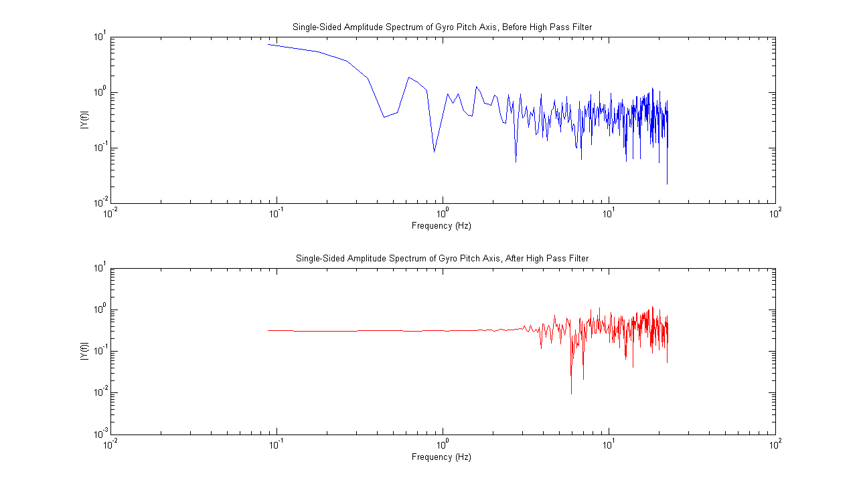

Figure 2. Gyroscope Filter Results